Karla Avila

12/15/17

COMM 105G

Rule-Breaking, Communication and Deception?

In most multiplayer games, communication with the members of your team is extremely important. You have to be able to communicate well with them so you can collaborate on a game strategy and win. This is true for most massively multiplayer online games, also known as MMO games, where you tend to be on a team to try to defeat another team or accomplish a goal. You would not think that being deceitful on a team would help you get a win, but this exactly the case in the game *Town of Salem*. Communication is essential in this game as well, but just as essential is being able to lie so that you can make it to the end of the game without dying and thus winning. This is very counterintuitive to what other MMO games need to win, but it is just as important and I will argue that it’s even more so critical. *Town of Salem* is a unique MMO for this exact reason, but it also has similar aspects of other MMO’s in that player’s rage quit the game after they die even though this is against the rules. Rule-breaking and communication make this game similar to other MMO’s, but being deceitful makes it unique.

During this course, it was my first time ever playing *Town of Salem*. When I was first trying to figure out how to play, I looked around to see if there was any tutorial on how to start. To my surprise, I could not find one but I did see that there were some rules right before you play. It was discretely hidden in plain sight; you would not think to click on it unless you took a look around (Image 1). I then took a look at the rules to see if it could help me learn how to play the game before just jumping into it. There were quite a few rules, some I did not quite understand since I had never played the game before. Some were intuitive, like do not leave the game even after you die or don’t share what role you are playing. There was another one saying “No Gamethrowing” which I could not quite comprehend. It mentioned that intentionally losing for your own team is gamethrowing, which I was not sure about at first. They did give some examples of what gamethrowing was, which was very helpful in understanding (Image 2). Despite these rules being very clear on what you can and cannot do, people do not tend to listen to them. I have seen multiple people leave the game after they lose. There are some roles that can talk to the dead and even bring someone back from the dead so if you leave the game after dying, you ruin the chances of your team winning the game. If your team wins, then you also win and it helps your rank and profile so leaving the game won’t help your rank go up. Another rule is “No Inappropriate Names”, which was not always followed in some games I played. There was one round where somebody was named “Donald Trump” and he kept messaging that he’s going to “build the wall” and tried saying “grab them by the pu**y” but the game would not let him say that. I also encountered somebody slut shaming me, indirectly since they did not know my role, for being the escort and “distracting” them. They thought it was unfair but said so in a inappropriate game that got that player killed after a few rounds. There was also another round where my name was “chickennugget” and one player said I must be fat and ugly because that was my screen name. They were soon killed because of the constant bullying but ended up being the jester and that was their goal all along so they could get their revenge on all of us who voted to kill him. That being said, there is not any serious repercussions for breaking the rules. The worst that can happen is you are looked down upon and potentially killed during the game, but being banned from playing is not something that seems to happen. This makes *Town of Salem* similar to other MMO games.

Another similar aspect of *Town of Salem* to other MMO games is communication. *Town of Salem* is very similar to another game people play that is called *Mafia*. There are a lot of different rules for playing *Mafia*, but essentially there are different roles like innocent villager, serial killer, healer, sheriff and others. One person is in charge and gets to see what role everyone is, and all the other members must close their eyes to not see who is doing the killing or saving. During the day time when you can communicate, it is important to do so to try to figure out who is killing people. If you are the killer, you communicate to make yourself not seem like the killer to make it to the end and if you are a villager, you communicate to try to figure out who is doing the killing to kill them and win the game. Therefore, communication is an important aspect of this game. *Town of Salem* is essentially this game, with more roles and and the inclusion of a serial killer as well as the mafia. There is a little area of the computer screen on the bottom left where you can talk to the other members of the village. On the top of that chat, there is an area for members of the game who have died and the role they were, and an area where all the roles of the villagers are displayed. On the right side of the screen, it lists what role you are and how to play as that role. (Image 3). Communication with strangers might be a bit difficult on who you can and cannot trust, and even with friends there might be a bit of doubt in who to trust. As mentioned in Mark Chen’s article *“Communication, Coordination, and Camaraderie in World of Warcraft.”*, he mentions that friendship could be used to help the strategies of games as well as in other aspects like in school or work (Pg. 70). For this game, communication is important but since you cannot tell anyone what your role is, playing with your friends does not give you an advantage in this type of MMO like Chen argues in his article. While it does not necessarily give you an advantage, communication is much easier between friends rather than with complete strangers. When I played with my group, I was not entirely sure who they were since the screen names kept changing. That made it hard to talk to them individually and in the end we all were talking about who to kill and try to figure out who was what role. So while being friends can give you somewhat of an upper hand, in this game, it is not necessary for winning. In this way, *Town of Salem* is similar to MMO games in that communication is crucial in order to get your team to win the overall game.

Communication and deception go hand in hand for this game in order for you to be the last person standing to win for your team. While I mentioned that communication is imperative for being successful, I am going to argue that being misleading is equally as important or even more important that communication. Since it is hard for you to be deceptive without communication, I will agree that communication and deception is the same in the amount of importance. The whole point of *Town of Salem* is to make it until the end without dying so that you can win the game for you and your team. There are two major teams in this game, the villagers or townspeople and the mafia. If you are a part of the townspeople, you are trying to figure out who the members of the mafia are and trying to kill them while trying to save as many other townspeople as possible. As long as you are the last player as a villager, you win the game for your team. There are different roles within the villagers like sheriff or doctor, and they can help prevent deaths from happening at night. There are pretty important roles as townspeople and you do not want these people to be killed, so deception is important for these roles so that members of the mafia do not kill them and get an advantage. On the other hand, the mafia members want the townspeople to be bad at being sneaky so they can kill all the villagers. They do want to be misleading themselves though, so that the vigilante or villagers do not kill them and they lose the game. These two major groups want to win the game, and so they want to be dishonest on what their role is. Another role that is important in this game for being deceptive is the serial killer. They kill both mafia members and townspeople and want to make it until the end so they can win the game on their own. Since you are in this role by yourself, it is even more important for you to be insincere in what your role is when chatting with the other players. You have to constantly make suggestions on who they think is members of the mafia or who the serial killer is, albeit it is themselves. The last role I believe you have to be good at lying is the jester. The jester is a part of the townspeople, but their goal is to get the rest of the townspeople to lynch them publicly so that they die and can get their revenge from beyond the grave. This role seems like the hardest to be deceitful in to me. Not only do you have to be inconspicuous about your role as the jester, you have to make yourself seem like you are the serial killer or a member of the mafia to try to get the other members to lynch you because they believe you to be against their team. You cannot be too eager about wanting to die because then the other villagers will be suspicious of you and will not kill you publicly. They might kill you at night instead, and this is not your intention as the jester. You want to kill as many people as you can, so by having the village lynch you and getting the most amount of votes that say you are guilty as you can, you can accomplish this task. Essentially, for all of these roles it is necessary for you to not be entirely truthful about your role in order for you to win as any of the roles. Of course, the different roles have distinct goals that they want to achieve but for all of these roles, the same strategy to use is being misleading. This makes *Town of Salem* unique compared to other MMO games because in other games, you tend to communicate with your team but you do not tend to lie to your own team.

In the end, *Town of Salem* is distinctive from other MMO’s because, while rule breaking implicit rules and communication is common throughout all MMO games, being deceptive towards all the members in the game including your own team is a strategy that will help you win a game and not all other MMO’s have this as a strategy to win. I am not certain that all other MMO games actually allow you to communicate with the other teams, but since you can chat with the opposing team members, being ambiguous about your role is critical to win the overall game and increase your statistics and rank. *Town of Salem* has so many different aspects about it that you can study. If I had the chance to do this all over again, I would focus more on rule breaking within this game. There does not seem to be any serious consequences for breaking rules, so I would try to break some rules and see if anything happens to me for doing so. I would intentionally leave the game, try to gamethrow, and say controversial things to see how people would react. I would interview some of the other plays to see how they responded and try to come in contact with some of the creators of the game to see what they think of rule breaking and if they plan to implement any harsher repercussions.

**Sources:**

“Communication, Coordination, and Camaraderie in World of Warcraft.” Mark G. Chen, 2008. Games and Culture 4(1):47-73

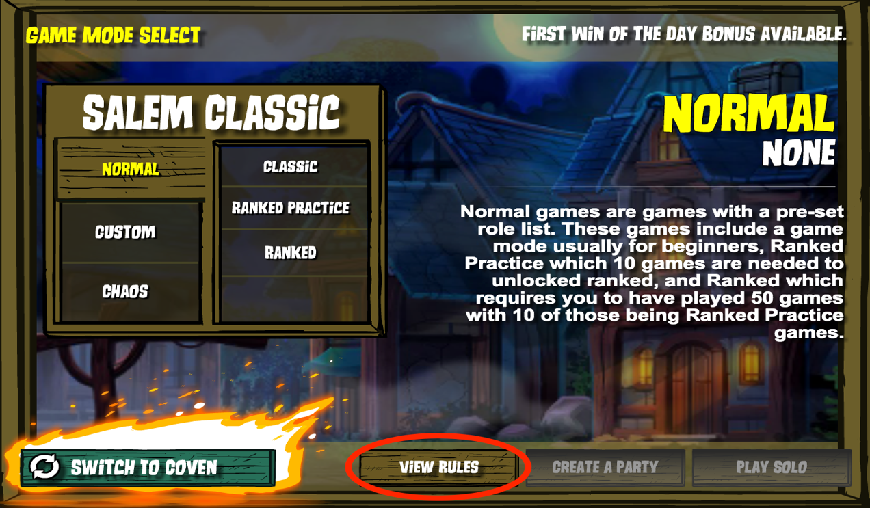

Image 1

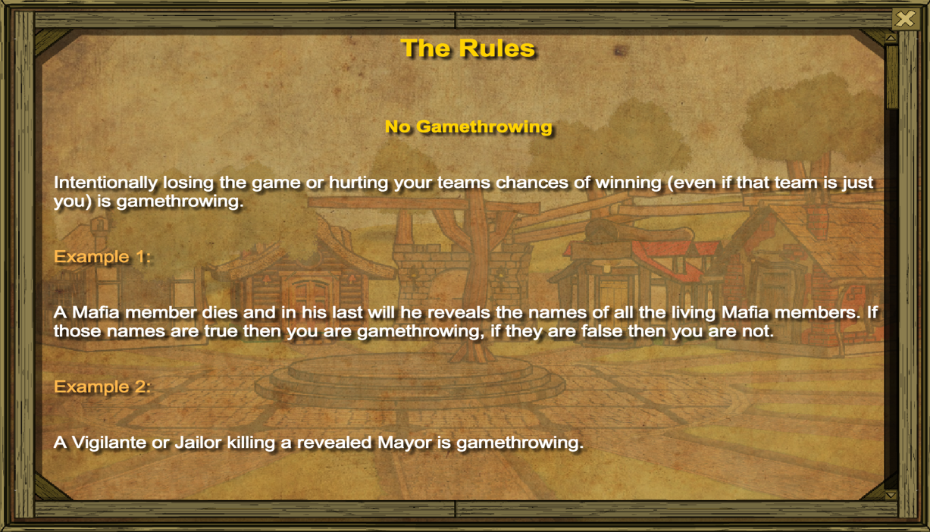

Image 2

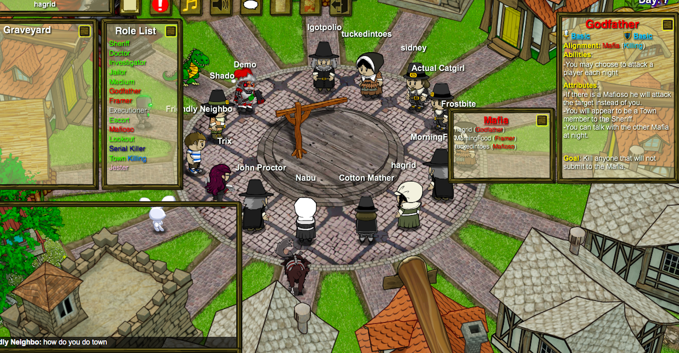

Image 3